# 

# 

# 

# **Moderation Analysis with dichotomous variable**

**Abstract**

In this day and age, it has become very difficult to find new jobs. This holds particularly true for females who are still subject to unspoken rules and biases against them. This study first starts off by investigating whether there’s a relationship between the Difficulty of Finding a New Job and Job Satisfaction. As such, the former will be our independent variables and the latter will be our prediction or dependent variables. The study also further explores if females, as a third variable, serves as a moderator to the IV and DV. That is to say, if it enhances or buffers the effect that the predictor (Difficulty of Finding a New Job) has on the outcome (Job Satisfaction).

**Introduction**

Population is on the rise but jobs are still scarce. Fresh graduates, and otherwise, all have had difficulty in obtaining employment because companies either demand experienced people or follow a very stringent requirement of hiring people from famous schools. The situation is even more difficult for females. Although movements have successfully managed to achieve equal rights for them, the thought that females are inferior to their men in almost every aspect is still very prevalent among the people, particularly in corporate jobs. Not only do women find it difficult to get employed, they face much higher obstacles when it comes to progressing in their careers.

All of these hurdles combined may introduce lower job satisfaction among the female employees. Organizations have begun recognizing this and have started work on making their workforce more diverse when it comes to their employees. They understand that, in order to secure and retain female talents, it is necessary to improve their employment and onboarding process such that females feel more welcome. Companies have launched women-specific employment programs to make jobs more accessible.

Therefore, this study analyzes two things. Firstly, it determines whether the ease in finding a new job affects an employee’s job satisfaction. Secondly, it carries out the same observation again but with a focus on employees. That is to say, females who normally face much more hurdles than men will have a higher or lower job satisfaction given the ease in searching for a new job.

**Background/Theory**

Job Satisfaction is defined as the level of contentment employees feel with their job. While this goes beyond their daily duties to cover satisfaction with team members/managers, for this context we will be restricting job satisfaction as the level of contentment employees feel with the work they do and what they achieve through it.

Find New is defined as the level of ease that a person faces in either switching to a new company or getting their first job.

Since, the study is investigating whether the Find New affects Job Satisfaction, then the former will be the Independent variable while the latter will be the dependent variable. As such, this will also be our first null hypothesis where we theorize that variety of work does not affect job satisfaction.

*Hi: There is no relationship between ease in finding new job and job satisfaction*

The studies are also investigating how the relationship between the two variables would vary when a third variable, female, is introduced. How the sex of a person interacts with the ease in finding a job to influence Job Satisfaction. Females could add onto a positive or negative relationship between the Independent and Dependent variables or even have no affect. As such, this will be our second null hypothesis where we theorize that female, as the third variable, has no effect on the relationship of the two variables.

*H2: Female, the third variable, does not have an effect on the relationship between ease in finding a new job and Job Satisfaction.*

**Methods**

To study the effect of ease in finding a new job as a female on job satisfaction we have used the General Society Survey (GSS) data. The GSS data has been studying the growing complexity of American Society and has been monitoring societal change since 1972. The dataset has 57061 records. Table 1 below shows the summary of the data.

Table 1

Means, standard deviations, and correlations with confidence intervals

|  |  |  |  |  |  |
| --- | --- | --- | --- | --- | --- |
| Variable | *M* | *SD* | 1 | 2 | 3 |
|  | | | | | |
| 1. JobSat | 3.30 | 0.81 |  |  |  |
| 2. Female | 0.56 | 0.5 | .00 |  |  |
|  |  |  | [-.01, .01] |  |  |
| 3. FindNew | 1.85 | 0.81 | .06** | .01 |  |
|  |  |  | [.04, .07] | [-.01, .02] |  |
|  | | | | | |

Note. M and SD are used to represent mean and standard deviation, respectively. Values in square brackets indicate the 95% confidence interval. The confidence interval is a plausible range of population correlations that could have caused the sample correlation (Cumming, 2014). * indicates p < .05. ** indicates p < .01.

We then do a simple slope analysis to interpret how the interaction between ease in finding a new job and female variable affect the level of job satisfaction.

**Results**

The regression with the interaction of the female variable with ease in finding a new job shows that Female and ease in finding a new job are both significant predictors of Job Satisfaction. Along with these two the interaction of the female variable and ease in finding a new job is also a significant predictor of job satisfaction. The p-value of Female variable is 0.000187, the p-value of ease in finding a new job is 2e-16 and the p-value of the interaction term is 8.02e-05. The effect size of the female variable on job satisfaction is 0.10 in other words if the respondent is a female then the job satisfaction would increase by 0.10. Similarly, the effect size of ease in finding a new job on job satisfaction is 0.082 i.e. a unit increase in the scale of ease in finding a new job would increase job satisfaction by 0.80. The effect size of the interaction term is -0.055. The summary of the regression model can be found below in Table 2.

Table 2

Summary of the model results

__________________________________________________________________________________________________________________

|  |
| --- |
| Call:  lm(formula = JobSat ~ Female * FindNew, data = GSS.data)  Residuals:  Min 1Q Median 3Q Max  -2.4107 -0.3281 -0.2454 0.6769 0.7546  Coefficients:  Estimate Std. Error t value Pr(>|t|)  (Intercept) 3.162810 0.019954 158.506 < 2e-16 ***  Female 0.106652 0.028542 3.737 0.000187 ***  FindNew 0.082618 0.009916 8.332 < 2e-16 ***  Female:FindNew -0.055795 0.014145 -3.945 8.02e-05 ***  ---  Signif. codes: 0 ‘***’ 0.001 ‘**’ 0.01 ‘*’ 0.05 ‘.’ 0.1 ‘ ’ 1  Residual standard error: 0.777 on 18581 degrees of freedom  (38476 observations deleted due to missingness)  Multiple R-squared: 0.004107, Adjusted R-squared: 0.003946  F-statistic: 25.54 on 3 and 18581 DF, p-value: < 2.2e-16 |
|
|
|
|
|

The slope analysis shows that the slope of ease in finding a new job when the gender is not female is significant since the p-value is 0 and has a positive effect of 0.08 on job satisfaction.

The slope of ease in finding a new job is significant when the gender is female since the p-value is 0.01 and has a positive effect of 0.03 on job satisfaction . From the slope analysis it seems that ease in finding a new job has a higher effect on job satisfaction when the gender is not female since the value of effect is 0.08.

Table 3

Summary of the simple slope analysis

__________________________________________________________________________________________________________________

|  |
| --- |
| SIMPLE SLOPES ANALYSIS  Slope of FindNew when Female = 0.00 (0):  Est. S.E. t val. p  ------ ------ -------- ------  0.08 0.01 8.33 0.00  Slope of FindNew when Female = 1.00 (1):  Est. S.E. t val. p  ------ ------ -------- ------  0.03 0.01 2.66 0.01 |
|
|
|
|
|

The interaction plot also shows that as the ease in finding a new job increases by each unit scale the level of job satisfaction increases for both male and female. The slope is higher when the gender is not female.

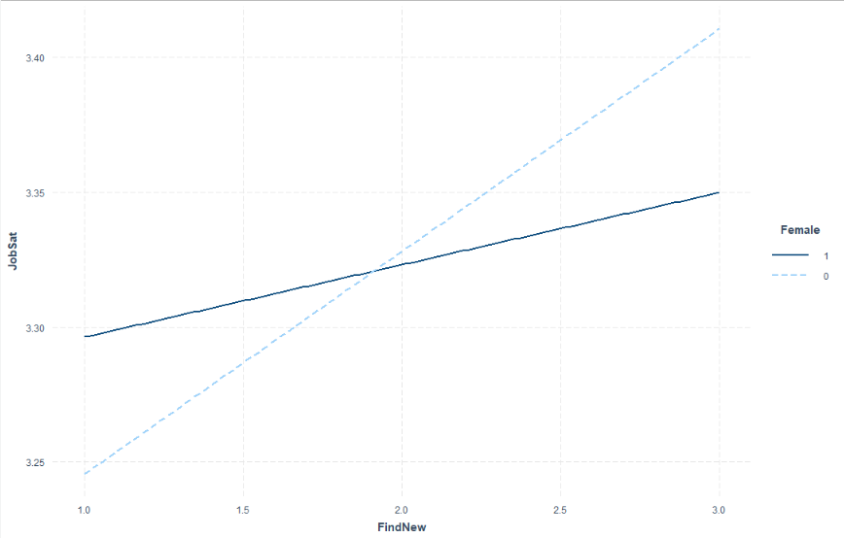

Figure 1: Interaction plot of ease in finding new job and female vs job satisfaction.

**Discussion** The regression result seems to show that there is indeed a positive relationship between ease in finding a new job and job satisfaction since ease in finding a new job is a significant predictor. Therefore, we can reject the first null hypothesis that there is no relationship between ease in finding new job and job satisfaction. We similarly saw that the interaction terms of ease in finding new job and female was a significant predictor of job satisfaction and from the slope analysis it was further confirmed that the slope of the variable ease in finding new job is significant and has higher positive effect on job satisfaction when gender is not female compared to when gender is female hence we can reject the second null hypothesis that female does not have any effect on the relationship between ease in finding new job and job satisfaction. This supports our theory because we initially said that female have lower levels of job satisfaction compared to men because of the discrimination in different spheres of life.

**Bibliography**

* *Dalfgauu, Jose. (2006). The effect of job satisfaction on job search.*
* *Adejoke, Ganiyat. (20017). A Study of Job Satisfaction among Women Workers*

**Appendix**

# GSS Data

The General Society Survey (GSS) has been studying the growing complexity of American Society and has been monitoring societal change since 1972. The aim of GSS is to gather data on contemporary American society in order to monitor and explain changes and constants in behaviors, attitudes and other attributes; to examine the functioning and structure of the society as well as understand the role different relevant subgroups play. The GSS aims to gather data on contemporary American society in order to monitor and explain trends and constants in attitudes, behaviors, and attributes; to examine the structure and functioning of society in general as well as the role played by relevant subgroups and to make high-quality data easily available for students, scholars, policy makers and others. The GSS includes questions like national spending priorities, crime, marijuana use and punishment, race relations, quality of life, confidence in institutions and so on and so forth. ("General Social Survey (GSS) | NORC.org", n.d.)

Code

#install packages

install.packages('interactions')

install.packages('apaTables')

#import packages

library(interactions)

library(apaTables)

#load data

source('GSS-CleanData.R')

# moderation

mydata <- GSS.data[c('JobSat','Female','FindNew')]

nrow(mydata)

apa.cor.table(mydata, filename="table1.doc")

# add interaction

Model.int.1 <- lm(JobSat ~ Female * FindNew, data = GSS.data)

summary(Model.int.1)

#simple slope analysis

sim_slopes(Model.int.1, pred = FindNew, modx = Female, johnson_neyman = FALSE)

interact_plot(Model.int.1, pred = FindNew, modx = Female)